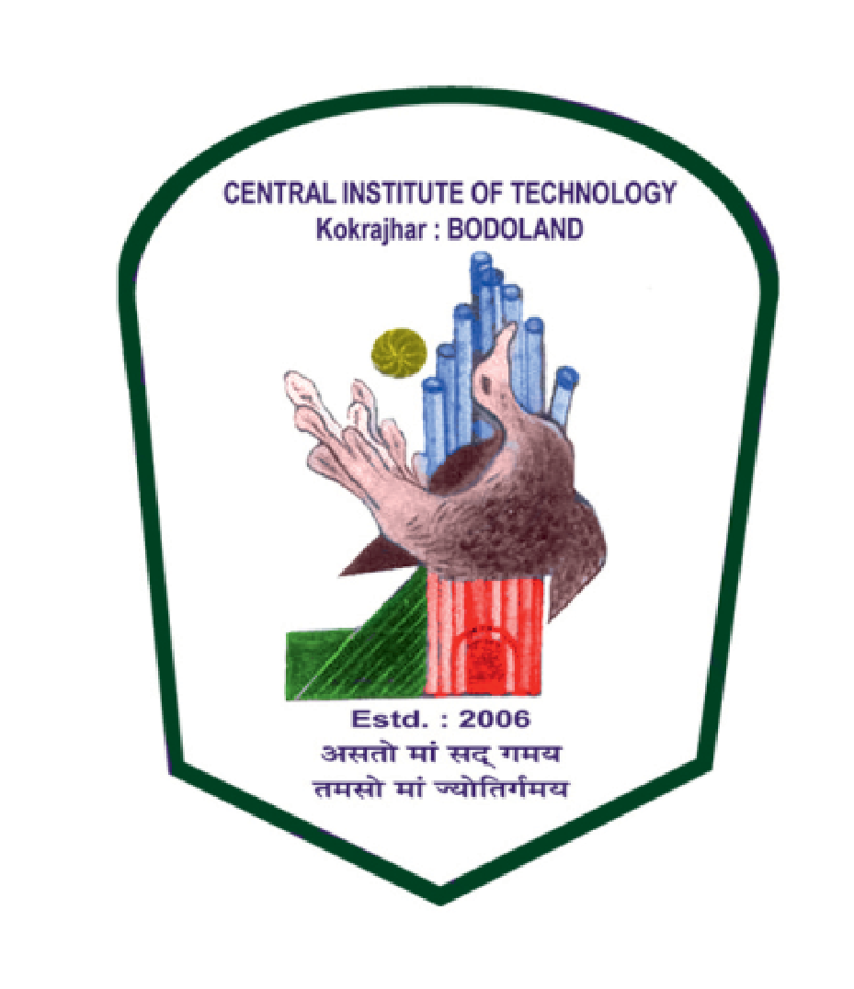
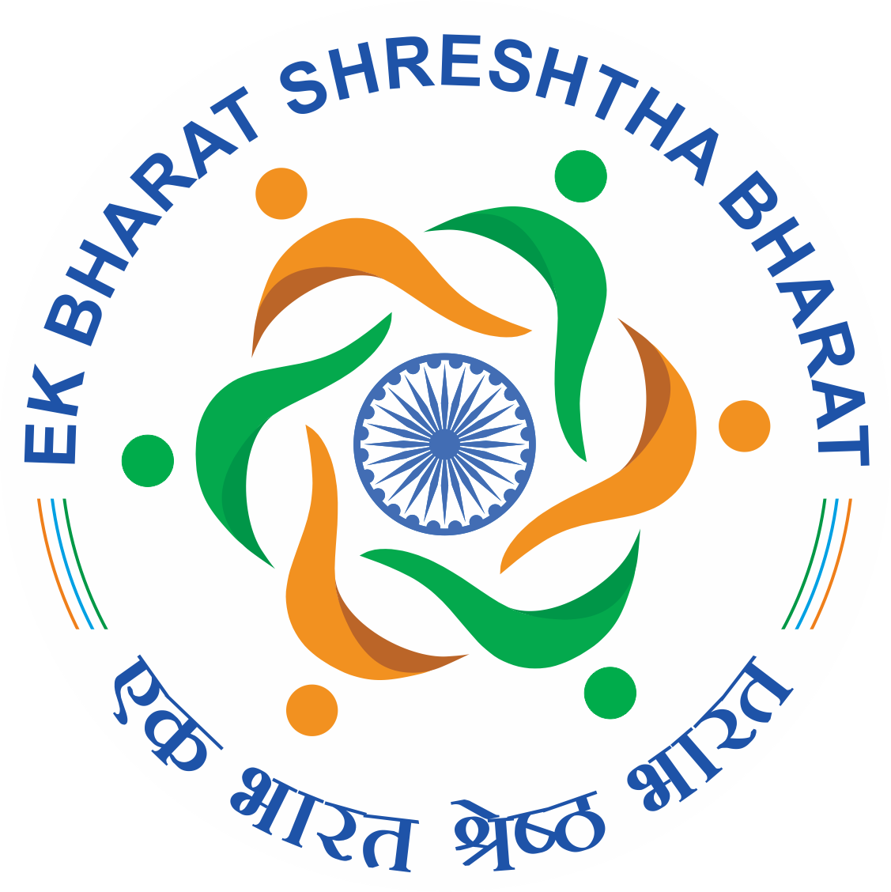
Invitation to 3rd Event of EBSB, CIT Kokrajhar
For Student Participants
Dear Students
Greetings for the day
Hope you all are doing well at your end.
The last two years were very challenging for all of us and taught us so many things to shape our habit and mind set. All of us put forward our best effort to cope up with the challenges and now our normal days are slowly coming up. On behalf of CITK, we are moving with some vibrant agenda to explore and share your skills and activities to acknowledge your creativity, under “Ek Bharat Shreshtha Bharat (EBSB)” Programme, launched on 31 October 2015 on the occasion of the 140th birth anniversary of Sardar Vallabhbhai Patel by the Hon’ble Prime Minister of India, Shri Narendra Modiji, which is already uploaded in Govt. Portal of EBSB.
Here, we are pleased to inform you that we are going to have our 3rd event “Exhibition on Ethnic Wear of Assam” on 25th November 2021, at 3:00 PM to 4.30PM. The whole programme will be on online mode and link will be shared with you. In this regard, you are requested to send your small presentations on ethnic dresses, its significance and utility in the region (Bodo wear, Assamese wear, Kachari wear, Rabha wear, Rajbanshi wear, Karbi Wear, Ahom Wear, Rabha Wear etc.)
You have to follow the criteria:
- The length of the presentation should be maximum 7 minutes & minimum 5minutes.
- Speaker should be CITK students.
- Group activity is more preferable.
- Need to send only to email id ebsb@cit.ac.in
- Presentations will be selected for the said event after proper review of committee members.
- Presentations will be assessed by the committee and the selected students will be notified accordingly.
- The last date of submission of the presentation is 24nd November 2021.
The selected presentations will be uploaded on the EBSB portal and the performers will be appreciated with a certificate of Performance.
Thus, we are looking for your active participation and all the students are encouraged to attend the programme and take part in mutual exchange of your thoughts. It is your programme, so come forward with your own idea and all.
All the best.
EBSB Committee
Central Institute of Technology Kokrajhar
(Deemed to be University, under MoE, Govt. of India)
Kokrajhar, B.T.R., Assam, India.

